From: https://blackboxvoting.org/fraction-magic-3/
FRACTION MAGIC – PART 3
PROOF OF CODE
By Bev HarrisMay 12, 2016COMPANIES, ELECTIONS INDUSTRY, MAKE AND MODEL, RESEARCH
No Comments
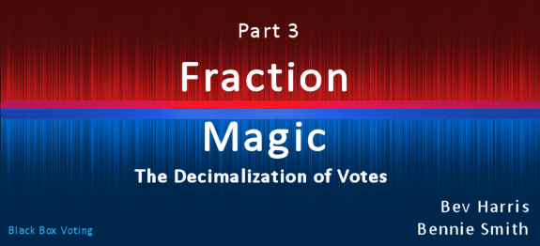

3 – PROGRAMMING TO TREAT VOTES AS DECIMALS –
The term “DOUBLE” means to store and process numbers with “double precision floating points” – in other words, to enable large numbers of decimal values.
In contrast, the term “INT” instructs the program to treat numbers as whole integers.
Source Code:
Below are clips from GEMS source code showing that it converts votes from whole numbers (previous version, GEMS 1.17) to store and process them as decimal values by setting them to “double” in GEMS version 1.18:
“ALTER TABLE SumCandidateCounter”
“ALTER COLUMN TotalVotes DOUBLE”
“ALTER TABLE SumRaceCounter”
“ALTER COLUMN NumberOfUnderVotes DOUBLE”
***
“CREATE TABLE SumCandidateCounter (
ReportunitId INT,
VCenterId INT,
CounterGroupId INT,
CandVGroupId INT,
TotalVotes DOUBLE )”
***
“CREATE TABLE SumRaceCounter (
ReportunitId INT,
VCenterId INT,
CounterGroupId INT,
RaceId INT,
TimesCounted INT,
TimesBlankVoted INT,
TimesOverVoted INT,
NumberOfUnderVotes DOUBLE ) ”
***
“ALTER TABLE CandidateCounter ”
“ALTER COLUMN TotalVotes DOUBLE ”
“ALTER TABLE RaceCounter ”
“ALTER COLUMN NumberOfUnderVotes DOUBLE”
***
# Contains the candidate counts for the race
“CREATE TABLE CandidateCounter (
CounterBatchId INT,
ReportunitId INT,
CounterGroupId INT,
CandVGroupId INT,
TotalVotes DOUBLE
# Number of votes ) ”
***
“CREATE TABLE SumCandidateCounter (
ReportunitId INT,
VCenterId INT,
CounterGroupId INT,
CandVGroupId INT,
TotalVotes DOUBLE ) “
***
Non-programmers may not have seen the term "double" used to describe processing numbers with decimals.
Here is an SQL tutorial -- there are many -- showing that "Double" means to process numbers as decimal values:
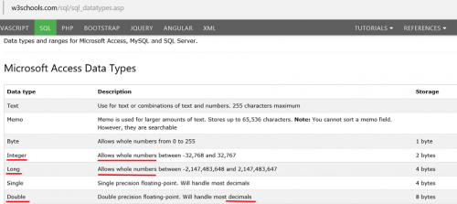

The above source code instructions create and define data structures in Microsoft Access tables, used by GEMS to create results reports. By opening the GEMS tables using MS Access, and right-clicking “design view” for the tables related to vote-counting, you see that the instruction to treat vote counts as “double” is implemented. The vote format in each is set to “double,” counting votes as decimals.
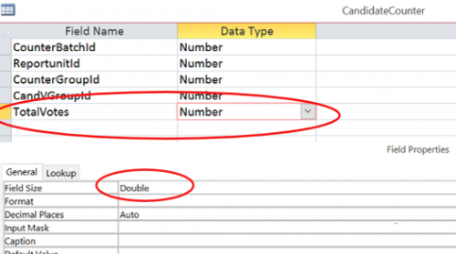

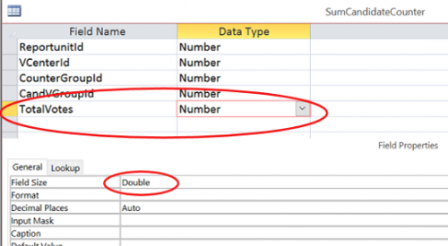

Overvotes are counted as whole numbers but undervotes are counted as decimals:
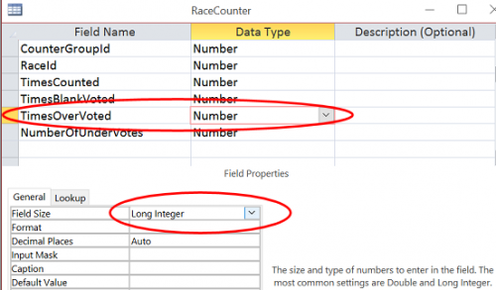

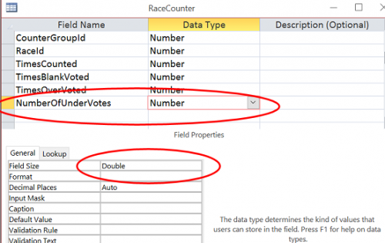

Because the “double” configuration for votes is built into the source code, the most important requirement for sophisticated, configurable election tampering exists wherever the program is used.

